Hypothesis:

# Identifying Null and Alternative hypothesis:



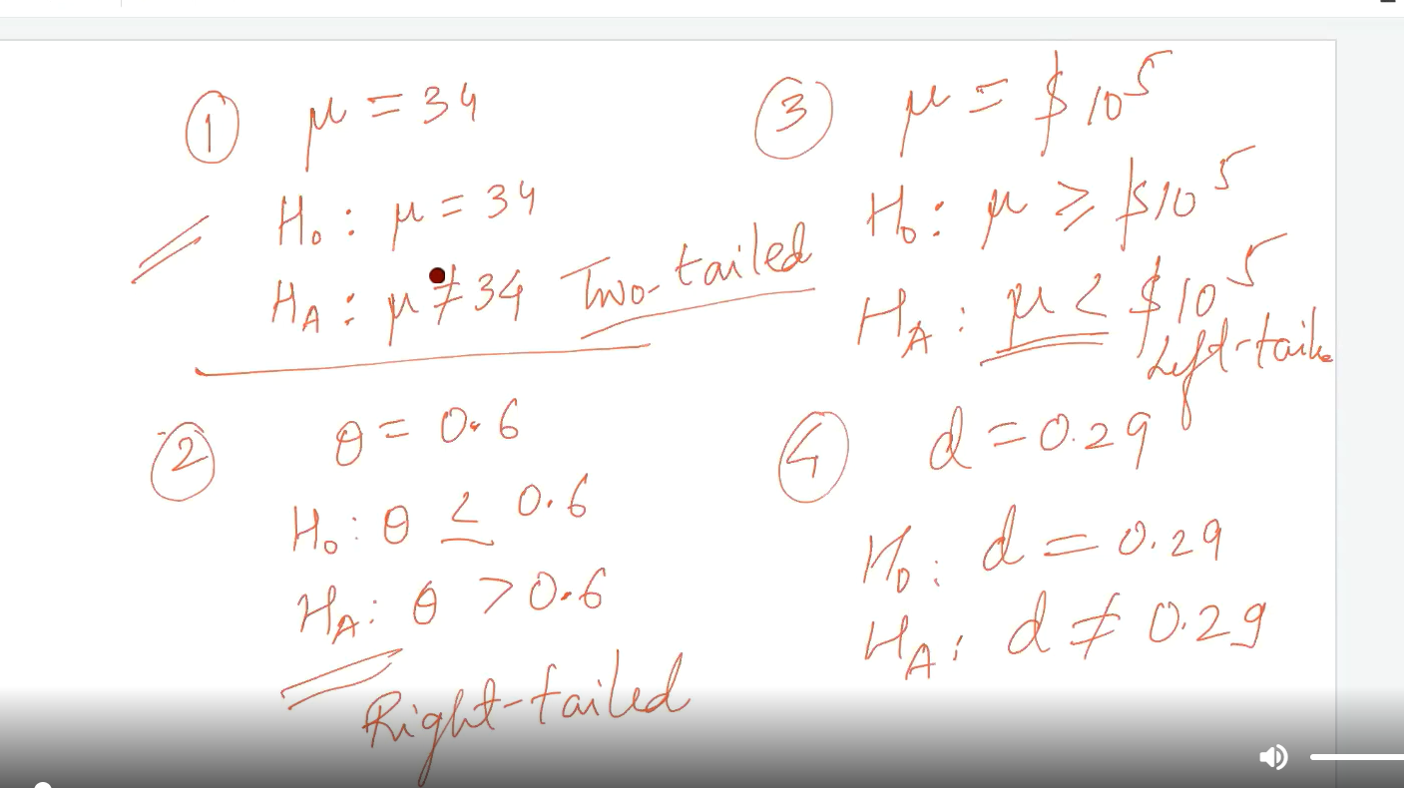

# Test statistics:

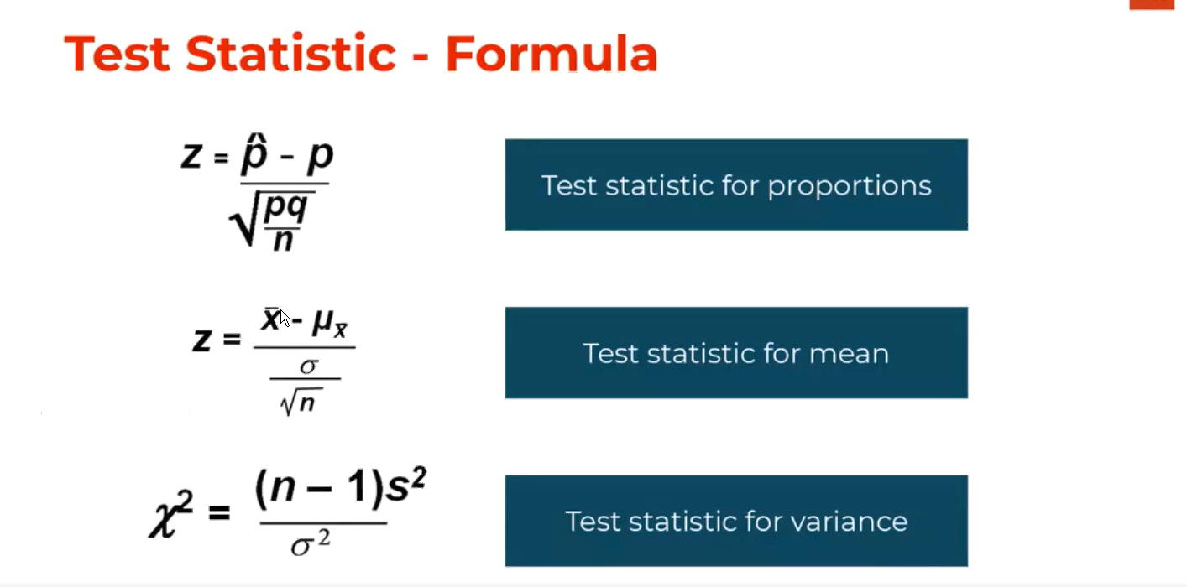

Here the test statistics is the conversion from sample statistics i.e p to normalized z statistics.

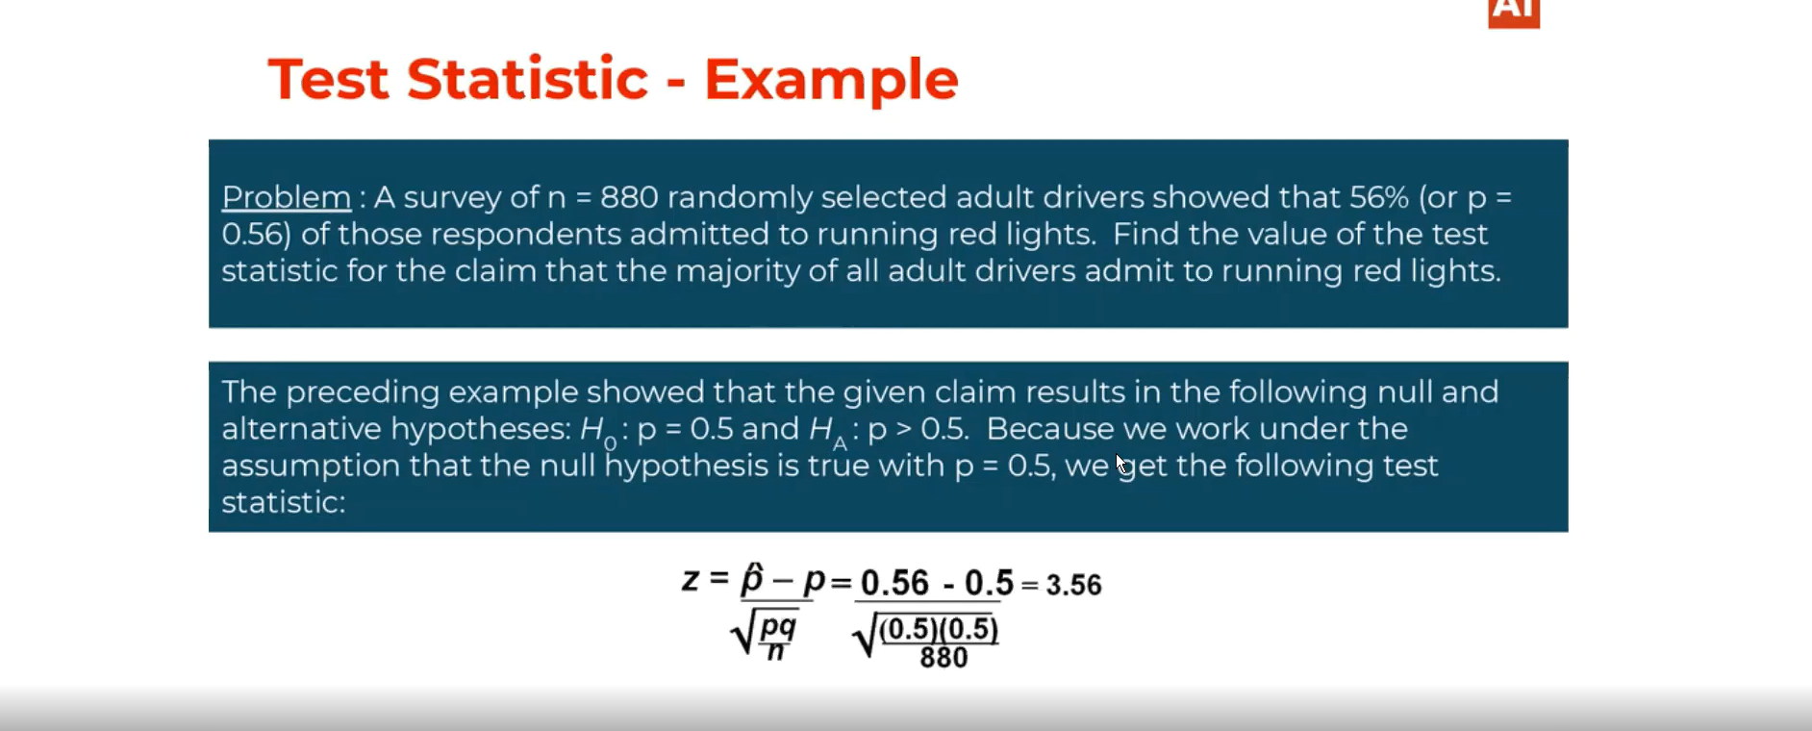

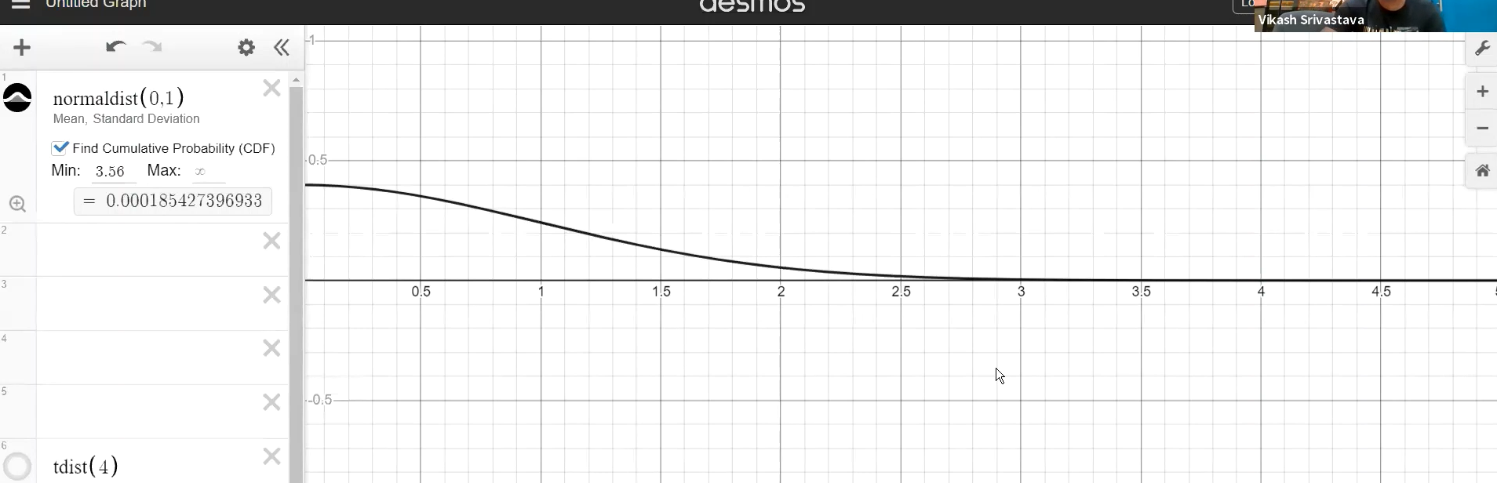

If the value of test statistics got from sample statistics is 3.56 then the probability of getting those situations or events are very rare.

# Significance level:

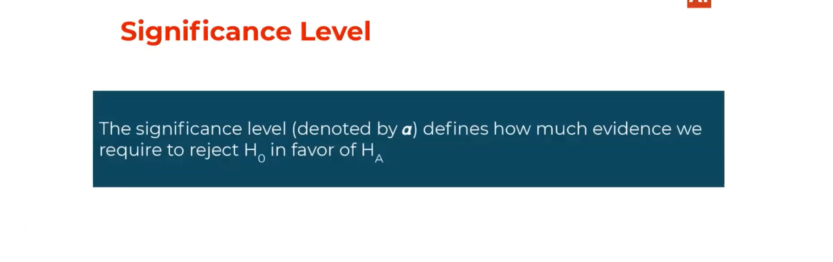

# Critical region:



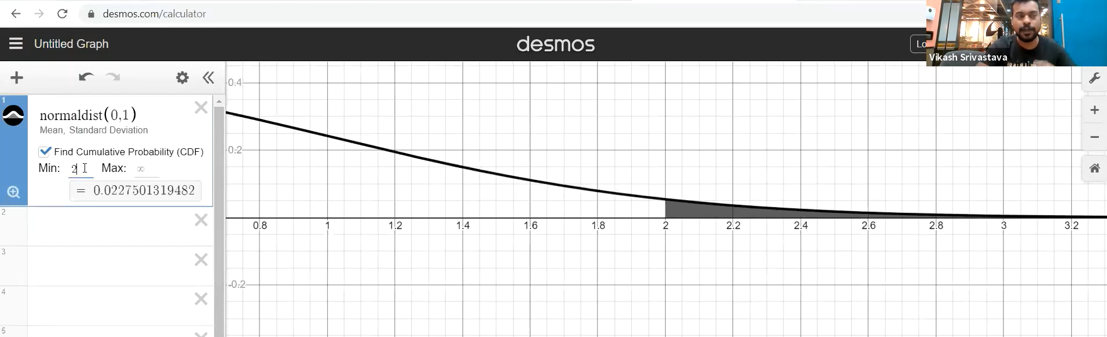

# Rare event: Due to rara event case here we are neglecting the alternative hypothesis.

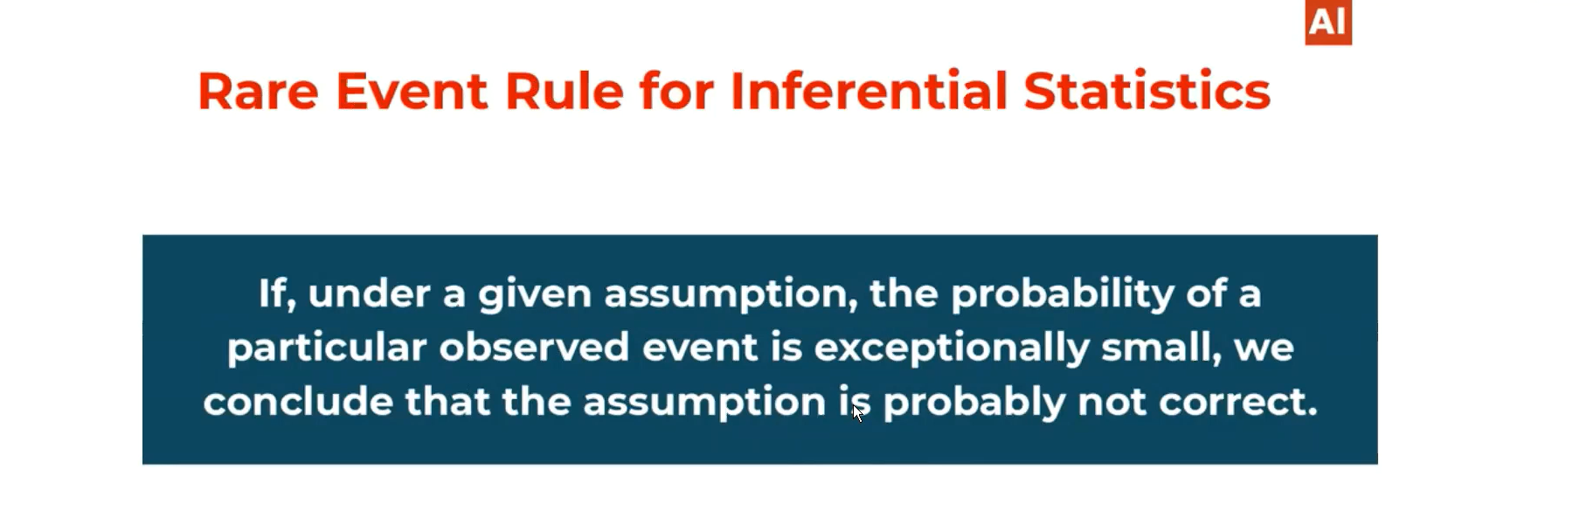

# P-value:

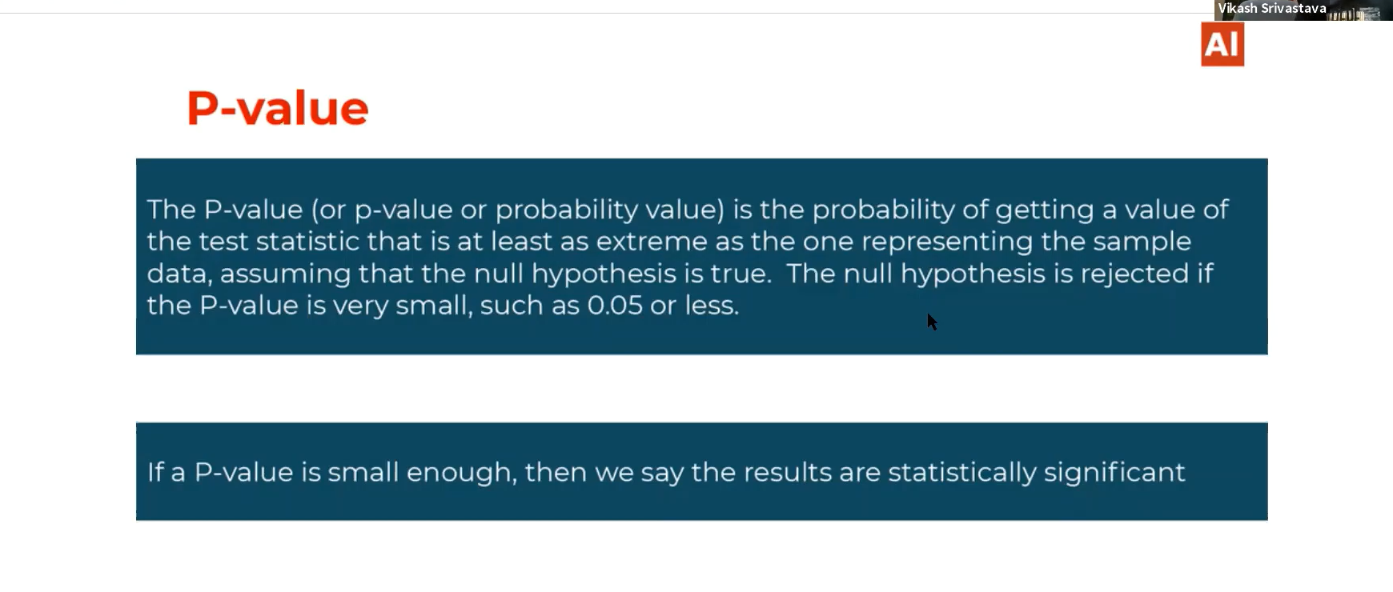

* Consider P value is very small than the significance value which we are operating. In this case we may get extreme values and we reject null hypothesis because we got the extreme values.
* P-value are the area covered by critical region.

# Statistically significant:

If we find enough evidence to reject null hypothesis then we can say our evidence are statistically significant.

# P-value v/s confidence interval:

Confidence interval talks about the range of values in which between the parameters lie and the p-value talks about the extreme values to reject the null hypothesis.

# Example:

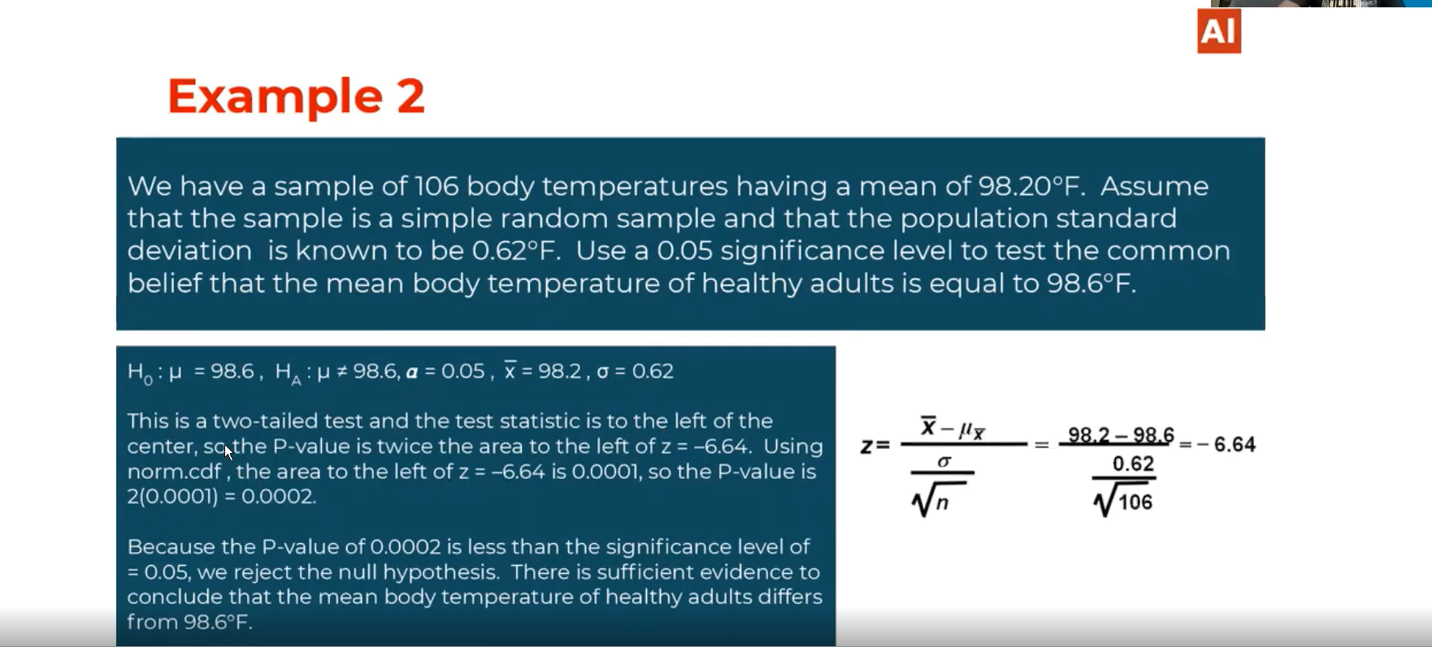

# Steps in Hypothesis testing:



# The relation between statistics and probability theory:

Without probability we can do the 3rd step. The Probability theory🡪 CLT🡪Statesticus

# Type I error:

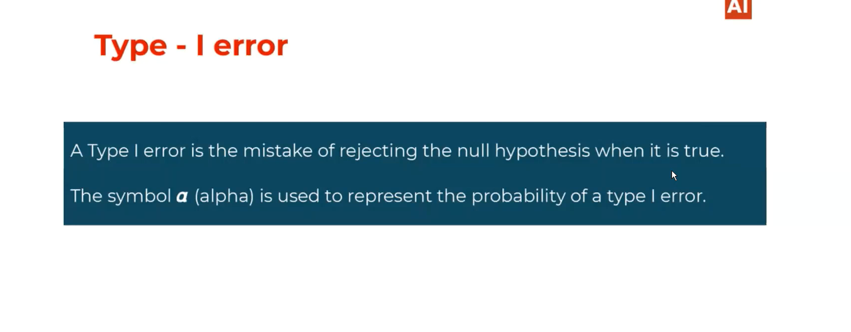

When we don’t have enough evidence to reject the null hypothesis but however, we rejected it then its called typeI error.

# TypeII error:

We failed to reject the null hypothesis when it is false.

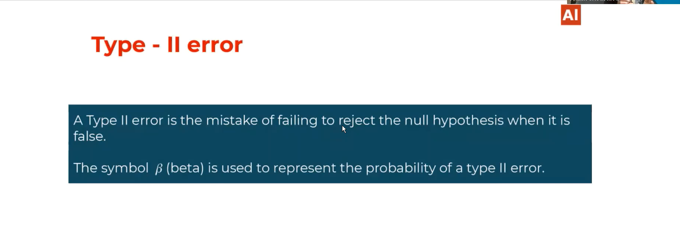

# TypeI and TypeII errors:

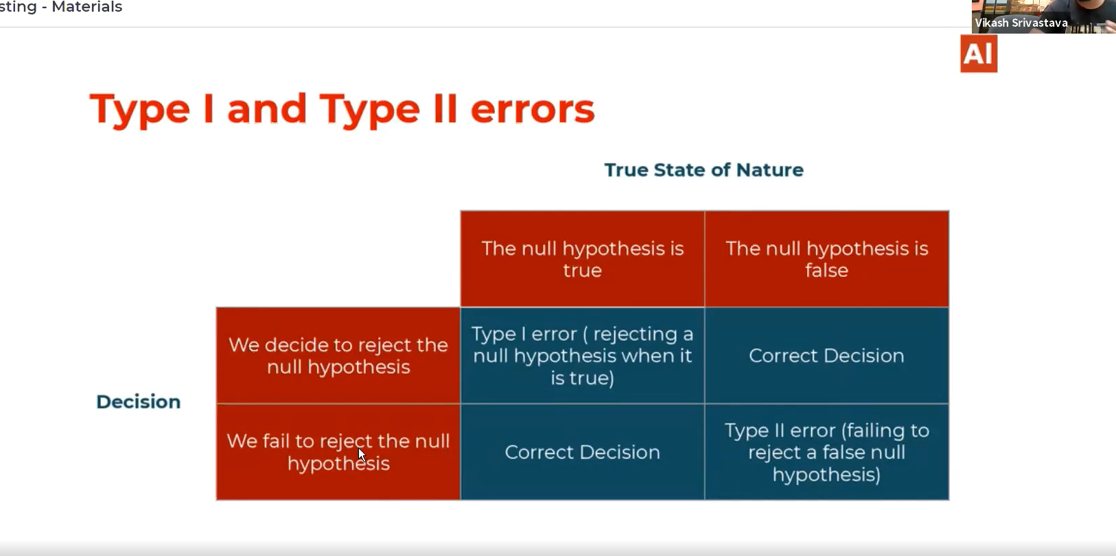

# Power of hypothesis test:

